PHENIKAA UNIVERSITY

PHENIKAA SCHOOL OF COMPUTING



WEEKLY REPORT

TOPIC: ELECTRONICS E-COMMERCE WEBSITE

Course Class : | Software Architecture-1-2-25 (N01)
Instructor : | M.Sc. Vũ Quang Dũng
Group : | 16
Group Members : | Nguyễn Tuấn Thiền - 23010571  Đặng Việt Anh – 23010689
Mục lục
Lab 01
1. Abstract/Summary 3
2. Lab Specific Section: Requirements Elicitation & Modeling 3
2.1 Software Requirements Specifications (SRS) 3
2.1.1 Actors Identification 3
2.1.2 Functional Requirements (FRs) 4
2.1.3 Non-Functional Requirements (NFRs) 4
2.1.4 Architecturally Significant Requirements (ASRs) 6
2.2 Modeling Artifact: UML Use Case Diagram 11
2.2.1 System Context Diagram 11
2.2.2 Main Use Case Diagram 11
2.2.3 Critical Path: Make Purchase (Checkout Process) 13
3. Architectural Design (Problem Analysis for Lab 2) 15
3.1 The Problem Statement 15
3.2 Impact of ASRs on Layered Architecture 15
3.3 Additional NFRs Mapped to Source Code (Supplement) 16
3.4 ASR Cards — Additional Patterns (Supplement) 17
4. Conclusion & Reflection 18
5. References 18

1. Abstract/Summary
The Electronics E-Commerce Website project aims to develop a robust online retail platform for electronic products. This initial lab focused on requirements elicitation and modeling. We documented essential Functional, Non-Functional, and Architecturally Significant Requirements (ASRs) in a structured format. The core system behavior was formally modeled using a UML Use Case Diagram, clearly defining system boundaries, external actors, and key behavioral relationships.
This foundation establishes the scope and the critical architectural drivers that will be addressed in subsequent labs, particularly the design of the Layered Architecture in Lab 2.

2. Lab Specific Section: Requirements Elicitation & Modeling
This section documents the deliverables for Lab 1, as specified in the report requirements.

2.1 Software Requirements Specifications (SRS)
The following tables document the elicited requirements, which collectively form the basis for the Electronics E-Commerce Website design.

2.1.1 Actors Identification
Based on the Electronics E-Commerce scenario, the following primary actors interact with the system:
Actor | Description | Interaction
Web Customer | End users who browse and purchase electronic products online | Browse products, register/login, add to cart, make purchases, submit reviews
Administrator | Store managers who manage the e-commerce platform | Manage products, categories, orders, articles, user accounts, and view reports
Payment Gateway | External payment processing system (VNPay, MoMo, PayPal) | Process payment transactions, verify payment information, return transaction status

2.1.2 Functional Requirements (FRs)
These requirements define the specific behaviors and functions the Electronics E-Commerce system must provide.
ID | Description | Priority
FR-01 | The system must allow a Web Customer to browse and search for electronic products using keywords and categories. | High
FR-02 | The system must allow a Web Customer to register an account and securely log in to the system. | High
FR-03 | The system must allow a Web Customer to add products to a shopping cart and manage quantities. | High
FR-04 | The system must support the Checkout process, including shipping information and payment processing (Make Purchase). | Critical
FR-05 | The system must allow a Web Customer to submit product reviews and ratings. | Medium
FR-06 | The system must allow an Admin to perform CRUD operations on product categories. | High
FR-07 | The system must allow an Admin to manage product inventory (add, edit, delete products). | High
FR-08 | The system must allow an Admin to view and update order statuses (Pending, Shipped, Completed). | High
FR-09 | The system must generate an order confirmation and send it to the customer upon successful purchase. | Medium
FR-10 | The system must allow an Admin to manage news articles/blog posts about electronics. | Low

2.1.3 Non-Functional Requirements (NFRs)
These requirements specify criteria that can be used to judge the operation of the system, not specific functions.
ID | Attribute | Description | Impact
NFR-01 | Performance | The Catalog Module must respond to 90% of product search and category listing queries within 2.0 seconds under normal load. This directly impacts the architecture by requiring query optimization at the Persistence Layer (Eloquent ORM caching) and efficient routing through the Catalog Module’s Controller-Model (Eloquent) stack with query caching (Cache::remember for 300s TTL). | High
NFR-02 | Security | All customer data, especially payment transactions processed through the Payment Module (VNPay, MoMo, PayPal), must be transmitted over HTTPS. User passwords must be hashed using bcrypt (Hash::make). Admin authentication must use a separate guard (“admins”) isolated from the Customer Module’s “web” guard, enforcing role-based access at the middleware layer (CheckLoginAdmin, CheckLoginUser). | Critical
NFR-03 | Availability | The system must maintain a minimum of 99.9% uptime during operational hours. Architecturally, this requires fault isolation between modules: a failure in the Notification Service (email sending) must not prevent the Cart Module from completing an order. This drives the adoption of the Outbox Pattern and asynchronous event-driven communication via Redis Queue between the main Laravel application and the Notification Microservice. Additionally, the CircuitBreaker middleware (app/Http/Middleware/CircuitBreaker.php) implements the Circuit Breaker pattern (CLOSED → OPEN → HALF_OPEN states) to prevent cascading failures across services, returning a 503 fallback response when a service exceeds its failure threshold. | Critical
NFR-04 | Scalability | The system must support at least 5,000 concurrent users during peak sales events. This drives the Modular Monolith architecture with clearly separated modules (Catalog, Cart, Payment, Customer, Review, Content, Support, Admin), enabling future decomposition into independent Microservices. The Kong API Gateway is introduced for rate limiting and load distribution across services. | High
NFR-05 | Usability | The Presentation Layer (Blade templates in resources/views) must deliver a responsive UI optimized for both desktop and mobile devices. The Catalog Module’s product listing and the Cart Module’s checkout flow must render correctly across screen sizes, impacting the separation between Presentation and Business Logic layers in the MVC architecture. | Medium

2.1.4 Architecturally Significant Requirements (ASRs)
These are the non-functional requirements that have the most profound influence on the system's architecture, driving the selection of patterns. If not met, the system is deemed a failure.
ASR ID | Quality Attribute | Requirement Statement | Architectural Rationale
ASR-1 | Scalability | The architecture must support horizontal scaling from 500 to 5,000 concurrent users during seasonal peak sales. The system is structured as a Modular Monolith with 8 isolated modules (Catalog, Cart, Payment, Customer, Review, Content, Support, Admin), each with its own Controllers, Models, and Routes, enabling future decomposition into independent microservices. | Drives the Modular Monolith pattern with the Strangler Pattern for gradual microservice extraction. Each module (Catalog, Cart, Payment) has isolated business logic, enabling Kong API Gateway load balancing and independent scaling of critical services like Order and Payment. The CircuitBreaker middleware (CLOSED→OPEN→HALF_OPEN) prevents cascading failures during peak load by returning fallback 503 responses.
ASR-2 | Security | All access to administration functionalities must be restricted via the dedicated “admins” authentication guard with CheckLoginAdmin middleware. Customer authentication uses a separate “web” guard with CheckLoginUser middleware. Payment processing through VNPay, MoMo, and PayPal must use secure token validation and callback verification (IPN/Return URLs). | Forces dual authentication guards in Laravel (config/auth.php) with separate middleware for Admin and Customer modules. The Payment Module isolates third-party gateway callbacks (MoMo IPN, VNPay Return) behind CheckLoginUser middleware, ensuring secure token validation at the routing layer.
ASR-3 | Modifiability | Integrating a new third-party Payment Gateway (e.g., adding PayPal alongside existing VNPay and MoMo) must not require changes to the Catalog Module, Customer Module, or Cart Module. The Payment Module (Modules/Payment/) must encapsulate all payment logic with a unified PaymentController interface. | Enforces the Modular Monolith pattern where each module (Catalog, Cart, Payment, Customer, Review, Content, Support, Admin) has its own Controllers, Models, Routes, and Views under Modules/{ModuleName}/. The Payment Module’s PaymentController handles all gateway-specific logic, so adding a new payment method only requires changes within Modules/Payment/ without touching other modules.

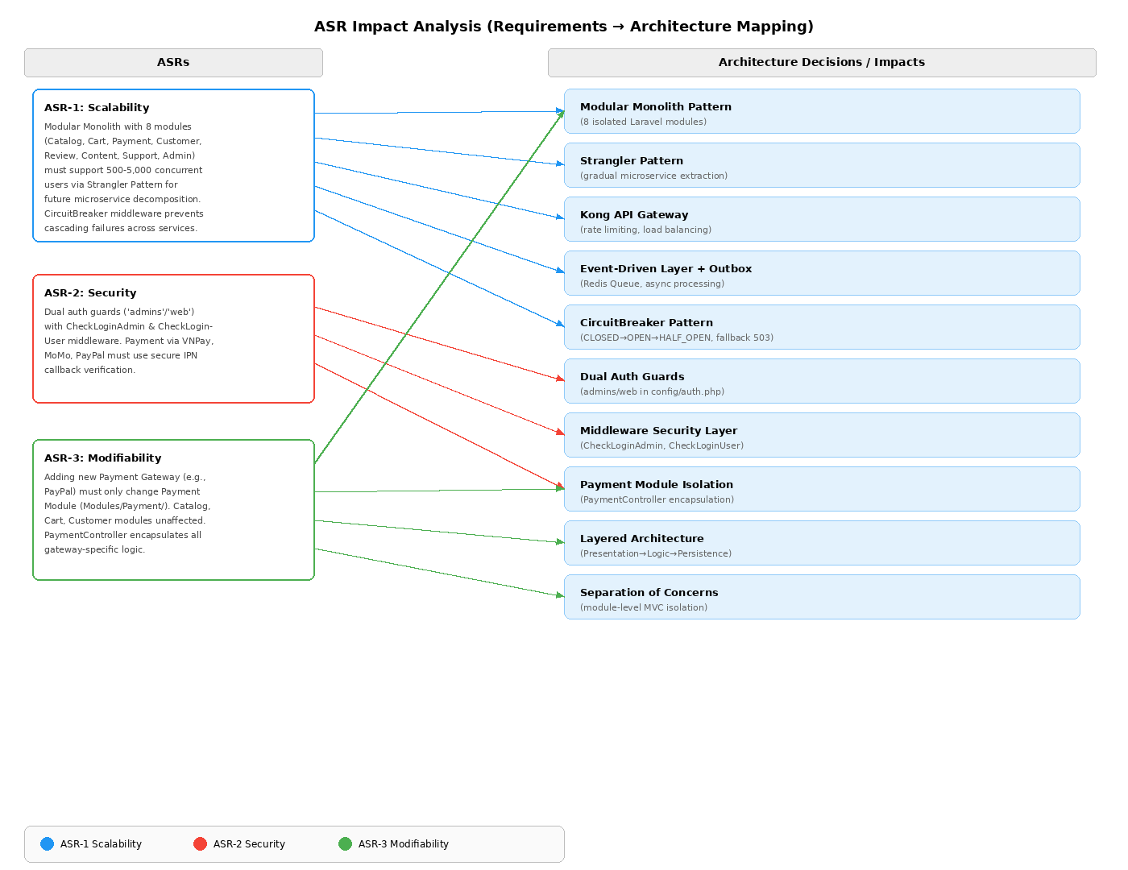
Figure 2.1: ASR Impact Analysis - Requirements to Architecture Mapping

Detailed ASR Cards:
ASR Card 1: High Scalability
- ASR: High Scalability (NFR)
- Statement: The system must handle a surge of 5,000 concurrent active users during peak sales events. The Modular Monolith with 8 modules (Catalog, Cart, Payment, Customer, Review, Content, Support, Admin) must support future decomposition into independent microservices via the Strangler Pattern.
- Impact: Drives the Modular Monolith architecture with isolated modules under Modules/{ModuleName}/. Enables Kong API Gateway for rate limiting and load balancing. The Event-Driven Layer with Outbox Pattern (outbox_messages table) and Redis Queue ensures asynchronous processing for non-critical operations like email notifications. The CircuitBreaker middleware further prevents cascading failures during peak load by isolating failing services.
ASR Card 2: Security & Access Control
- ASR: Security (NFR)
- Statement: Customer passwords must be hashed with bcrypt (Hash::make). Payment processing via VNPay, MoMo, and PayPal must use secure callback verification (IPN endpoints). Admin access uses a separate “admins” guard with CheckLoginAdmin middleware, completely isolated from the Customer Module’s “web” guard.
- Impact: Forces dual authentication guard configuration in config/auth.php with dedicated middleware layers (CheckLoginAdmin, CheckLoginUser) at the routing level. The Payment Module encapsulates all gateway-specific security logic (MoMo IPN verification, VNPay return URL validation, PayPal callback handling) within Modules/Payment/App/Http/Controllers/PaymentController.php.
ASR Card 3: Modifiability & Loose Coupling
- ASR: Modifiability (NFR)
- Statement: Adding a new payment gateway (e.g., PayPal alongside VNPay and MoMo) must only require changes within the Payment Module (Modules/Payment/). The Catalog, Cart, Customer, and other modules must remain unaffected.
- Impact: Enforces the Modular Monolith pattern where each module has its own MVC stack (Controllers, Models, Views, Routes) under Modules/{ModuleName}/. The Layered Architecture within each module ensures Separation of Concerns: Presentation (Blade), Business Logic (Controllers/Services), and Persistence (Eloquent Models) are strictly layered with downward-only dependencies.

2.2 Modeling Artifact: UML Use Case Diagram
The UML Use Case Diagram models the functional scope of the Electronics E-Commerce system, showing the system boundary, the external Actors, and the core Use Cases.

2.2.1 System Context Diagram
The System Context Diagram shows the system boundary and how it interacts with external entities.
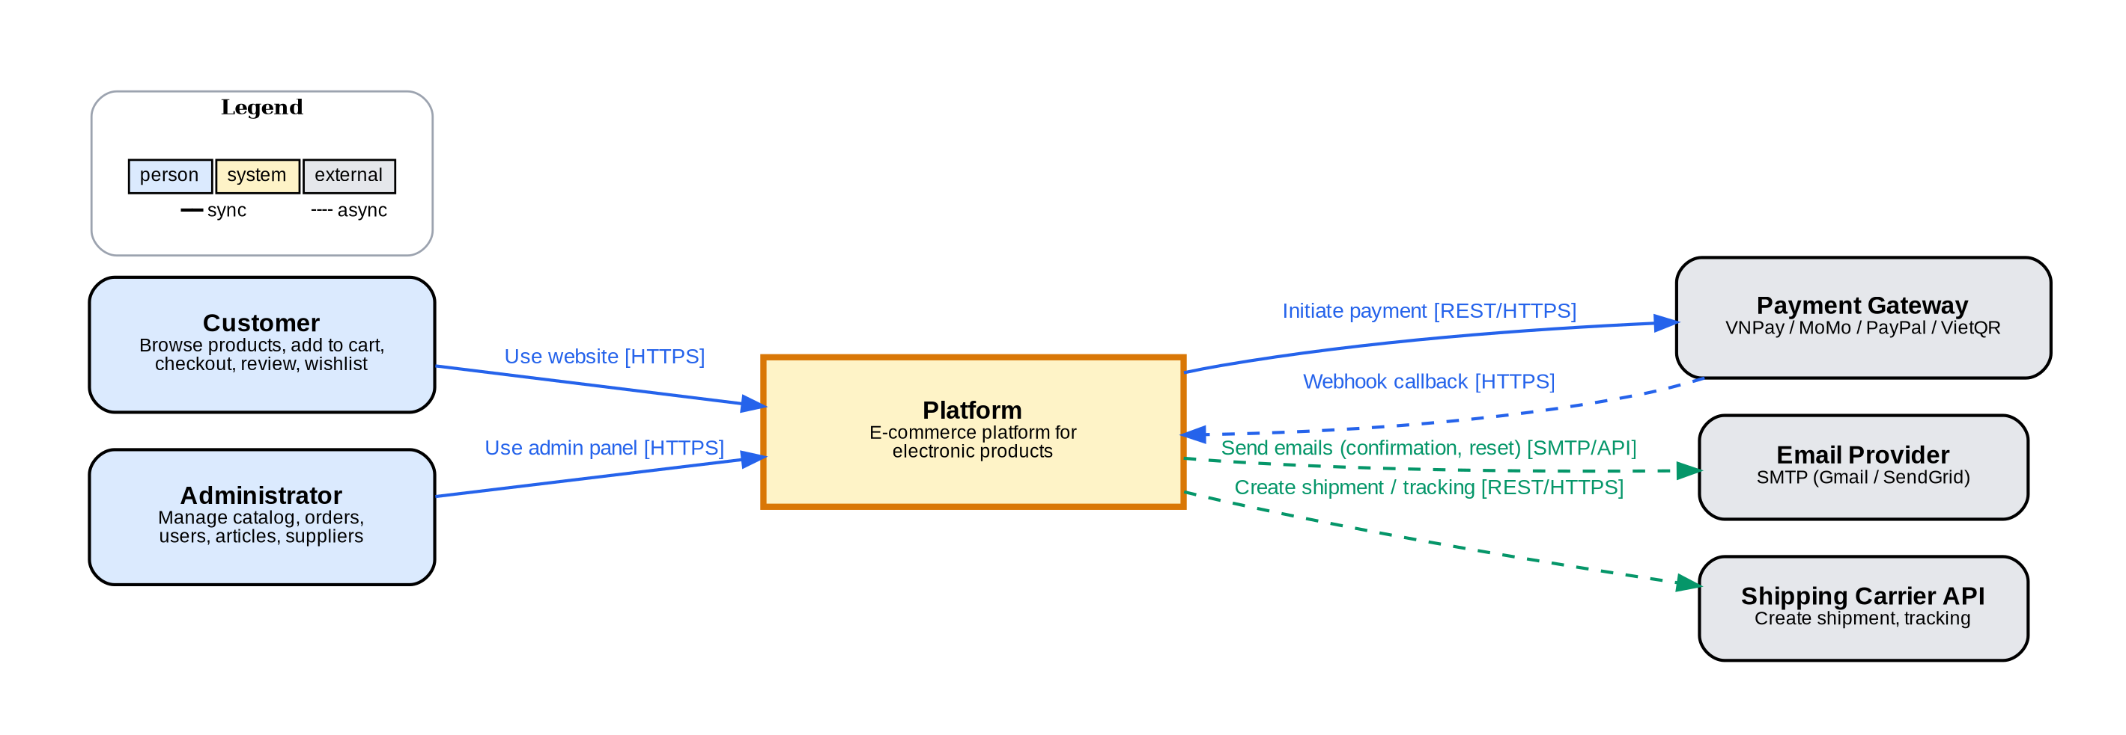
Figure 2.2: System Context Diagram - Electronics E-Commerce Platform

2.2.2 Main Use Case Diagram
The main Use Case Diagram shows all actors, use cases, and their relationships within the system boundary.
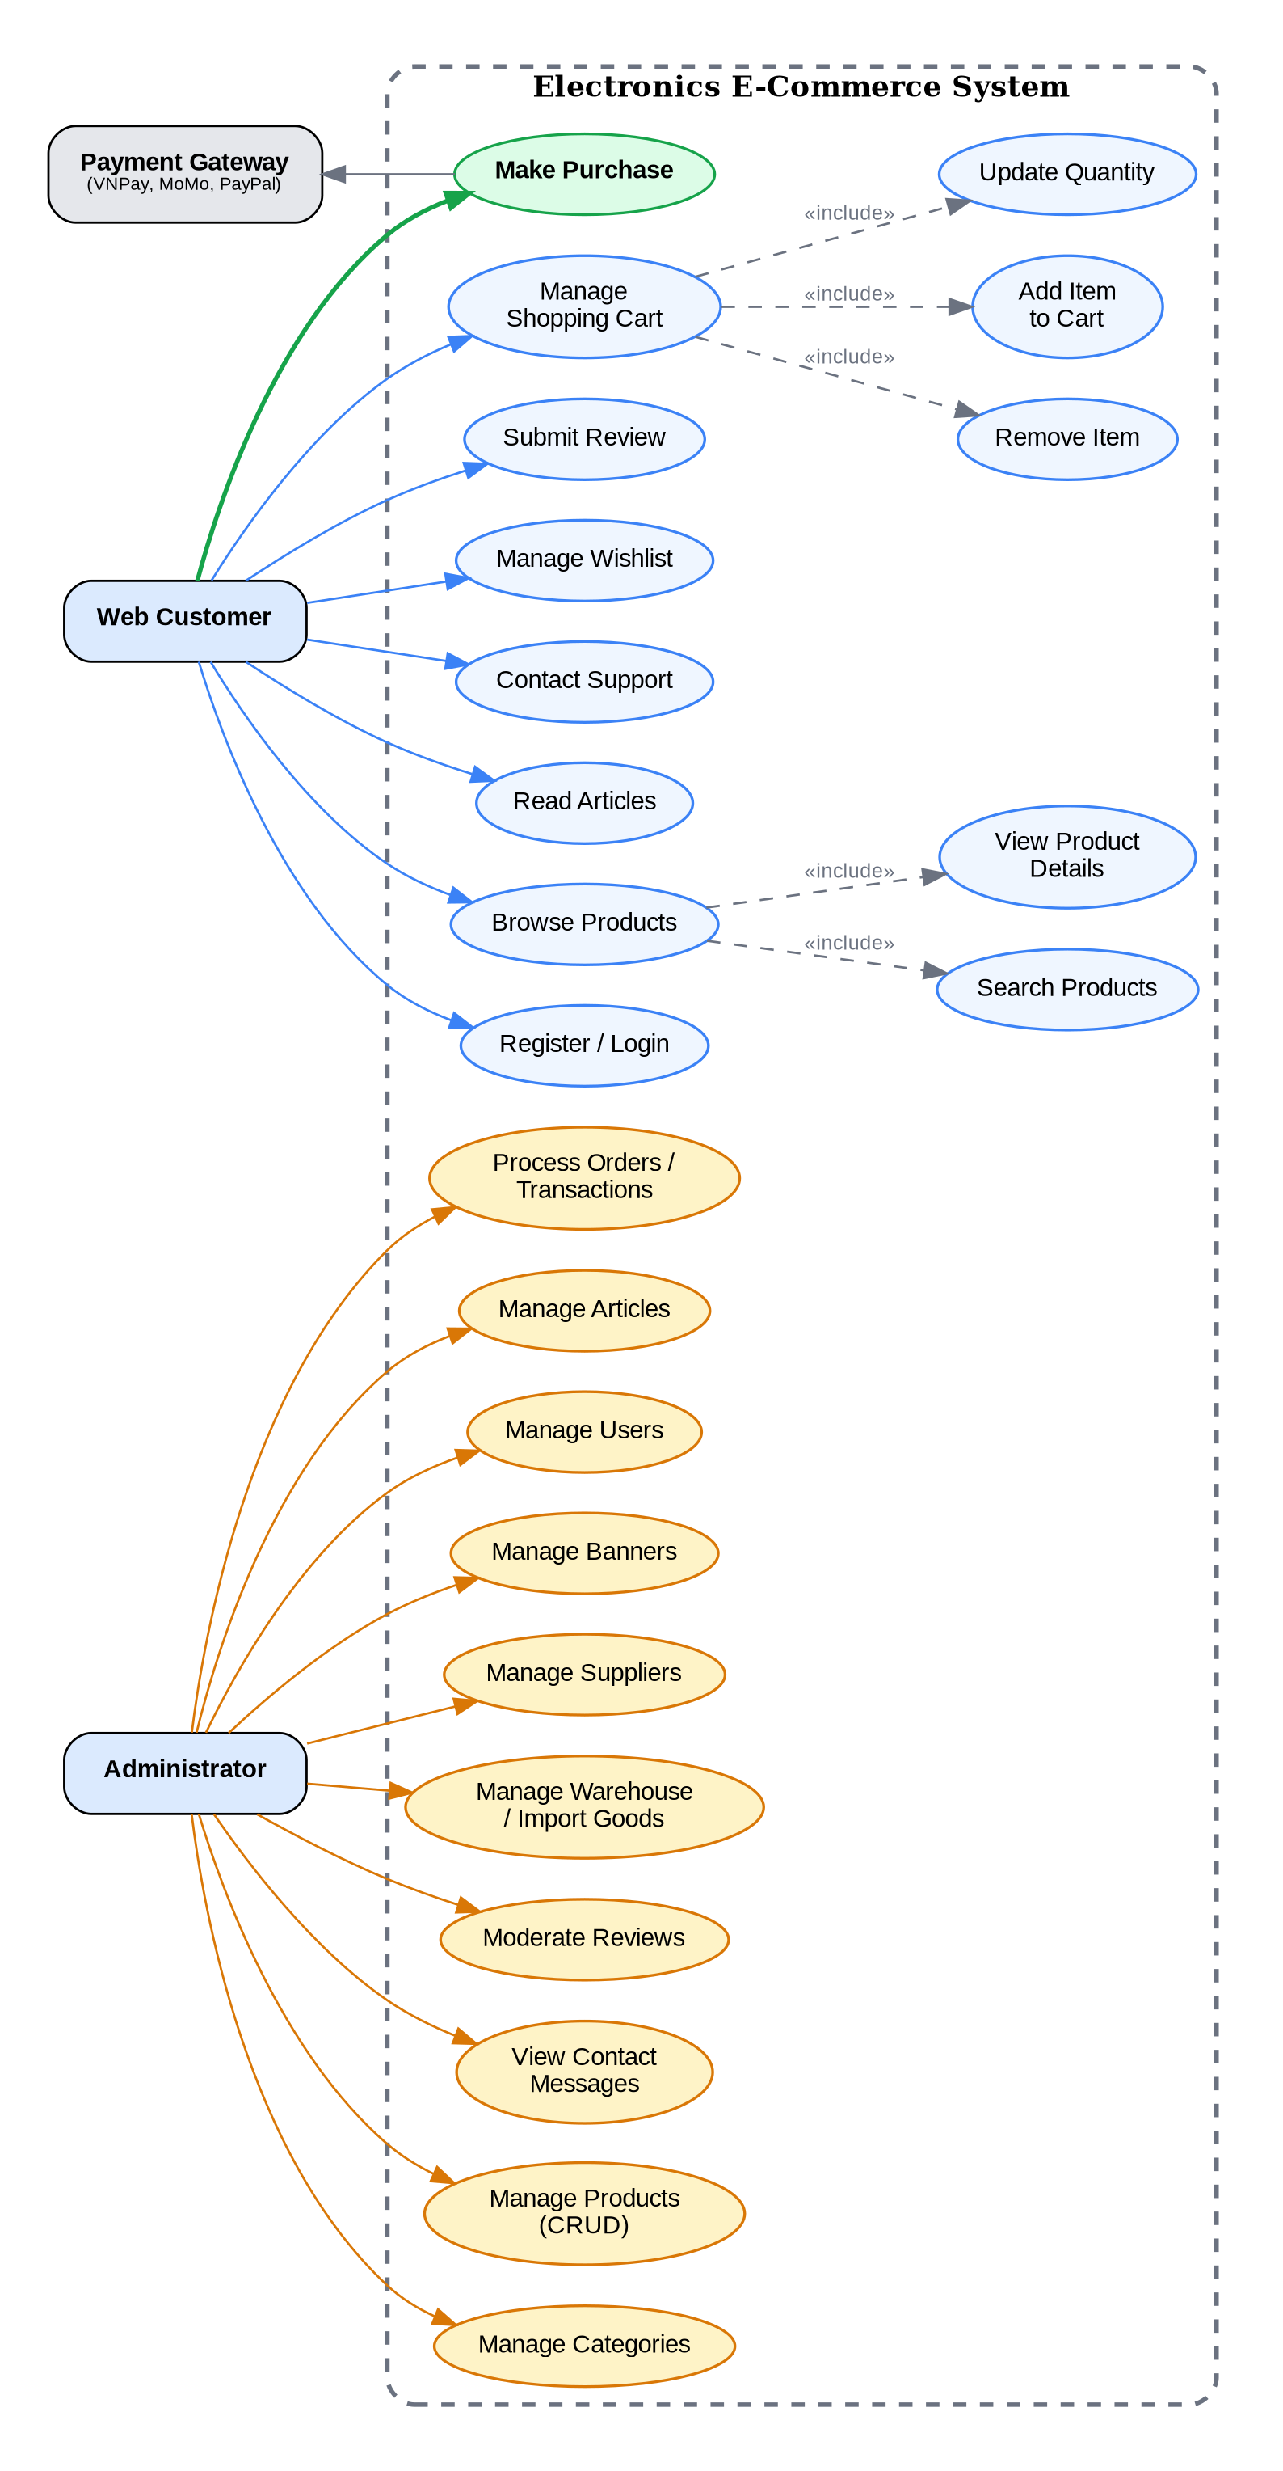
Figure 2.3: UML Use Case Diagram - Electronics E-Commerce System
Note: Figure 2.3 shows both customer-facing and administrative use cases. The Checkout (Make Purchase) flow is detailed separately in Figure 2.4 with include/extend relationships.
Actors (overall):
- Web Customer: End users who browse, search, and purchase electronic products.
- Administrator: Store managers who manage products, orders, and system content.
- Payment Gateway (External): Third-party payment processing service (VNPay, MoMo, PayPal).
Customer Use Cases:
- Browse Products - Search and view electronic products by category
- Register/Login - Create account and authenticate
- Manage Shopping Cart - Add, remove, update product quantities
- Make Purchase - Complete the checkout process (Critical Path)
- Submit Review - Rate and review purchased products
Administrator Use Cases:
- Manage Categories - CRUD operations on product categories
- Manage Products - Add, edit, delete product inventory
- Process Orders - View and update order statuses
- Manage Articles - Create and publish news/blog posts
- Manage Reviews - View and moderate customer reviews

2.2.3 Critical Path: Make Purchase (Checkout Process)
The diagram below details the Checkout process, which is the critical path for the system. It shows the include and extend relationships as required by Lab 01.
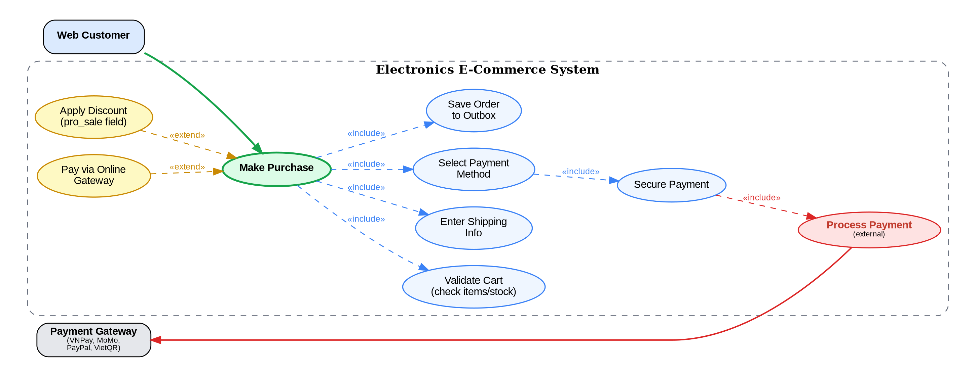
Figure 2.4: Detailed Use Case Diagram - Make Purchase (Checkout Process)
Use Case Relationships:
Relationship | Use Cases | Description
<<include>> | Make Purchase -> Validate Cart | Mandatory: Cart must be validated before checkout.
<<include>> | Make Purchase -> Enter Shipping Info | Mandatory: Shipping information is required.
<<include>> | Make Purchase -> Select Payment Method | Mandatory: Payment method must be selected.
<<include>> | Select Payment -> Secure Payment | Mandatory: Payment is processed through Payment Gateway.
<<include>> | Secure Payment -> Process Credit Card | Mandatory: External dependency on Payment Gateway (VNPay, MoMo, PayPal) to process and verify the financial transaction.
<<extend>> | Apply Coupon Code -> Make Purchase | Optional: Customer may apply a discount coupon.
<<extend>> | Pay via Online Gateway -> Make Purchase | Optional: Customer may choose to pay via online gateway (VNPay, MoMo, PayPal) instead of Cash on Delivery (COD). This triggers the Payment Module’s PaymentController to initiate the selected gateway flow.

3. Architectural Design (Problem Analysis for Lab 2)
The requirements elicited in Lab 1 have a direct impact on the design challenge of Lab 2: Layered Architecture Design.

3.1 The Problem Statement
The problem is to design an architecture for the Electronics E-Commerce Website that satisfies the identified ASRs while enforcing separation of concerns. The system adopts a Modular Monolith pattern built on Laravel MVC framework, with 8 isolated modules (Catalog, Cart, Payment, Customer, Review, Content, Support, Admin). Each module follows the Layered Architecture internally (Presentation → Business Logic → Persistence → Data) to address the Modifiability and Security ASRs.

3.2 Impact of ASRs on Layered Architecture
ASR-3 (Modifiability) -> Layered Structure:
ASR-3 demands that component changes remain isolated. For example, adding PayPal as a new Payment Gateway only requires modifications within Modules/Payment/ (PaymentController.php and its routes), without affecting the Catalog Module or Customer Module. The Modular Monolith with Layered Architecture inherently supports this: the Presentation Layer (Blade views), Business Logic Layer (Controllers/Services), and Persistence Layer (Eloquent Models) within each module have strictly downward dependencies. Changes to the Payment Module’s business logic do not propagate to the Catalog Module’s product listing views.
ASR-2 (Security) -> Business Logic Layer:
ASR-2 requires rigorous authorization for admin tasks. In the Layered Architecture, this is enforced at the Middleware Layer: the CheckLoginAdmin middleware protects all Admin Module routes (Modules/Admin/routes/web.php), while CheckLoginUser middleware protects customer-specific operations like checkout and reviews. The dual authentication guards (“admins” and “web” defined in config/auth.php) ensure that security checks are applied consistently at the Business Logic Layer of each module, protecting services like AdminProductController and CartController from unauthorized access.
The next step (Lab 2) will use these ASRs to formally define the four architectural layers within each module and model the logical components (Controllers like AdminProductController, CartController; Models like Product, Category, Order; and Views in Blade templates) and their interfaces within the Modular Monolith structure.

3.3 Additional NFRs Mapped to Source Code (Supplement)
NFR — Observability & Monitoring
Requirement: The system must provide centralized logging, distributed tracing, and metrics collection to enable rapid diagnosis of production issues. Response time for trace lookup must be under 5 seconds.
Architectural Impact: This NFR drives the adoption of the ELK stack (Elasticsearch + Logstash + Kibana) for centralized logging, Jaeger for distributed tracing, and Prometheus + Grafana for metrics collection. All services are configured through docker-compose.microservices.yml.
Source Code Evidence:
// config/services.php — Microservices Infrastructure
'elasticsearch' => [
'host' => env('ELASTICSEARCH_HOST', 'http://localhost:9200'),
],
'consul' => [
'host' => env('CONSUL_HOST', 'localhost'),
'port' => env('CONSUL_PORT', 8500),
],
'jaeger' => [
'host' => env('JAEGER_HOST', 'localhost'),
'port' => env('JAEGER_PORT', 6831),
'enabled' => env('JAEGER_ENABLED', false),
],
NFR — Data Consistency in Distributed Transactions
Requirement: Order processing must maintain data consistency across multiple services (Inventory, Payment, Shipping, Notification) even when individual services fail.
Architectural Impact: This NFR drives the implementation of the Saga Pattern (app/Services/Saga/OrderSaga.php) for orchestrating distributed transactions with compensation, and CQRS Pattern (app/Services/CQRS/) for separating read/write models to optimize performance and consistency.
Source Code Evidence:
// app/Services/Saga/OrderSaga.php — Saga Orchestrator
class OrderSaga {
private array $steps = []; // Ordered saga steps
private array $executedSteps = []; // For compensation on failure

public function execute(): bool {
foreach ($this->steps as $step) {
$step->execute($this->transaction);
$this->executedSteps[] = $step;
}
}

private function compensate(): void {
// Reverse order compensation
foreach (array_reverse($this->executedSteps) as $step) {
$step->compensate($this->transaction);
}
}
}

// app/Services/CQRS/ProductCommandService.php — Write Side
// app/Services/CQRS/ProductQueryService.php — Read Side (Elasticsearch)

3.4 ASR Cards — Additional Patterns (Supplement)
ASR Card 4: Distributed Transaction Consistency
- ASR: Data Consistency across Microservices (NFR)
- Stimulus: Customer places an order involving stock reservation, payment processing, shipment creation, and notification sending across 4 separate services.
- Response: The Saga Pattern orchestrates all steps sequentially; if any step fails, previously completed steps are compensated in reverse order.
- Impact: Drives implementation of OrderSaga with SagaStepInterface, including ReserveStockStep, ProcessPaymentStep, CreateShipmentStep, and SendNotificationStep. Each step implements both execute() and compensate() methods.
- Evidence: app/Services/Saga/OrderSaga.php + 4 step files in app/Services/Saga/Steps/
ASR Card 5: Read/Write Performance Optimization
- ASR: Performance Optimization for Read-Heavy Workload (NFR)
- Stimulus: E-commerce platforms have 100x more reads than writes (product browsing vs. product management).
- Response: CQRS (Command Query Responsibility Segregation) separates write operations (MySQL via ProductCommandService) from read operations (Elasticsearch via ProductQueryService with database fallback).
- Impact: Drives implementation of app/Services/CQRS/ with event-based sync (ProductCreated/Updated/Deleted events trigger Elasticsearch indexing via IndexProductToElasticsearch listener).
- Evidence: app/Services/CQRS/ProductCommandService.php, ProductQueryService.php, app/Listeners/IndexProductToElasticsearch.php
oMo/VNPay/PayPal instead of COD/Q

4. Conclusion & Reflection
The requirements elicitation phase for the Electronics E-Commerce Website successfully defined the project scope through detailed Functional, Non-Functional, and Architecturally Significant Requirements. The UML Use Case Diagrams provide clear visual models of user interactions and the critical checkout path.
Key takeaways from this lab:
- Architecture is Driven by NFRs: The 'how well' (NFRs) is often more important than the 'what' (FRs) when making architectural decisions.
- ASRs Dictate Patterns: Requirements like high scalability and security force choices away from simple solutions toward more sophisticated architectural patterns.
- UML Use Case View provides the initial contract between the system and the outside world, defining what the system does from an external perspective.
The identified ASRs—especially those relating to Modifiability, Security, and Scalability—directly necessitate the adoption of a structured pattern like the Layered Architecture for the subsequent design phase in Lab 2.

5. References
- Lab 1: Requirements Elicitation & Modeling - Course Materials
- Lecture 1: Software Architecture - Requirements Elicitation & Modeling
- Kruchten, P. - The 4+1 View Model of Architecture
- Ian Sommerville - Software Engineering, Ninth Edition, Addison-Wesley, 2011

